Tony Thompson Website & Branding Kit – Action Checklist

1. Branding Kit Integration
- Core Brand Elements
- Update logo: add one more block to reinforce the “T”
- Replace the picture on hero section
- 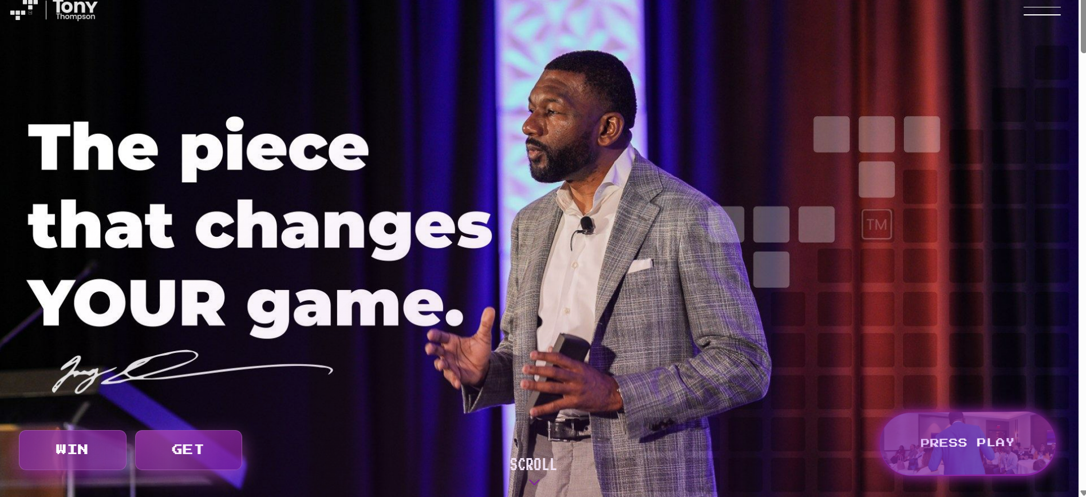
- 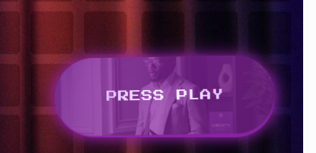
- Ad book Tony CTA
- 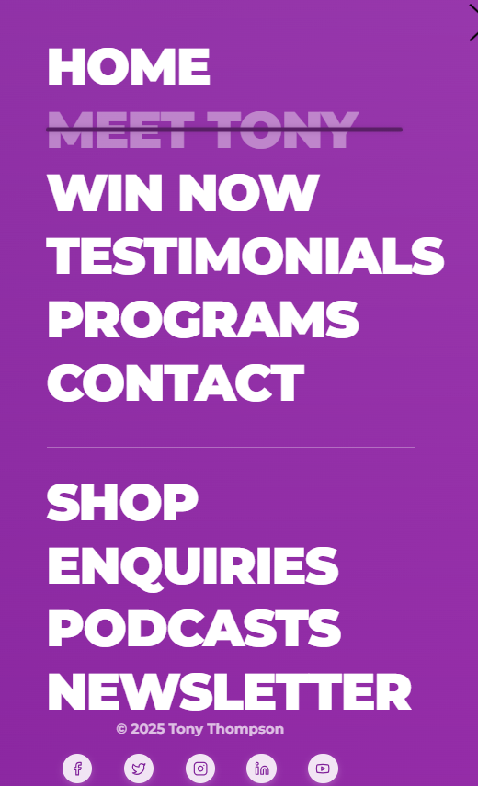
- AD Book Tony as part of this list, lesson font to make it look too crowded
- Change Enquiries to Inquiries
- 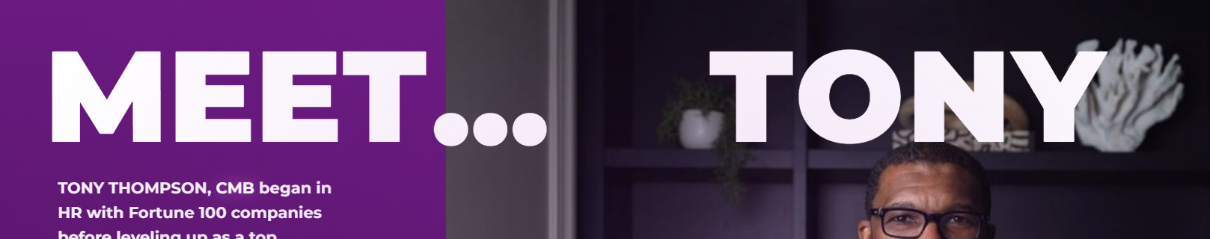
- Remove the right side and stack :tonys story (top and bottom on purple side)
- At bottom CTA remove step into Tony’s world to learn more
- 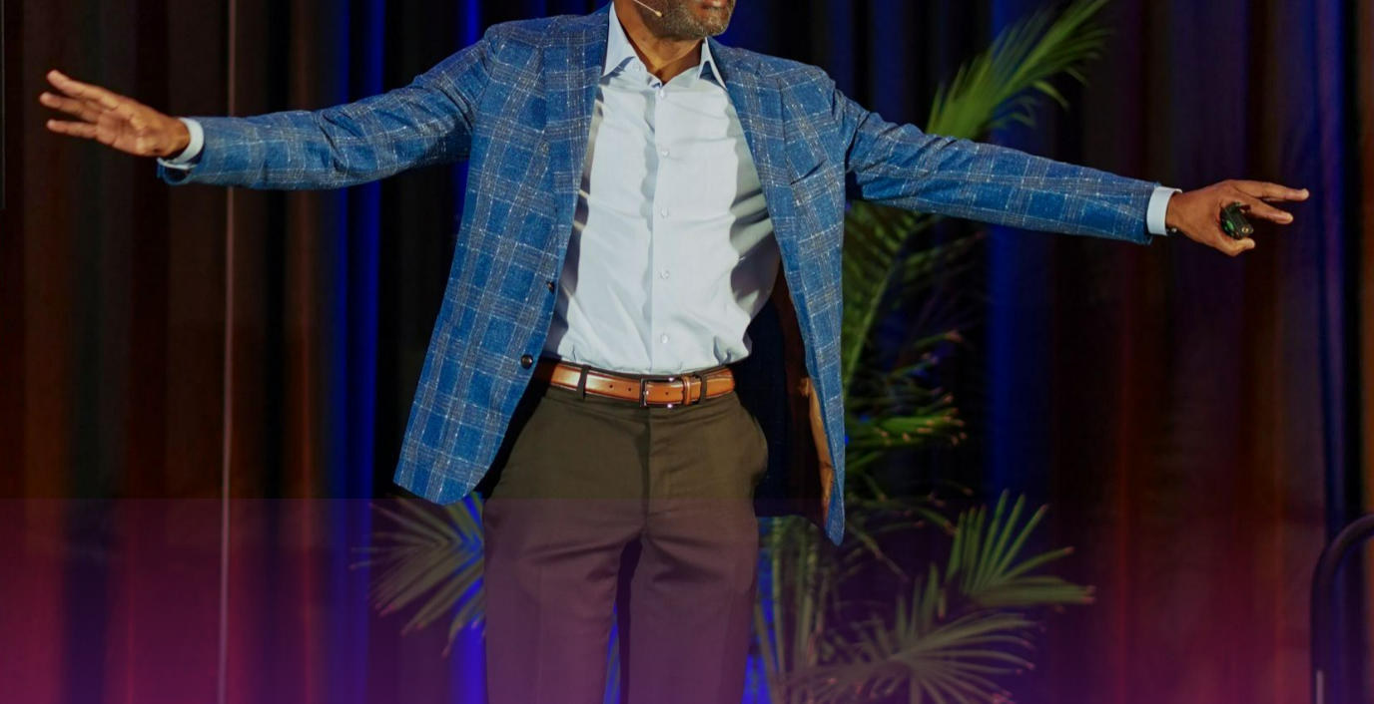
- In the explore section this picture is cute at the top and Tonys Head is not visible

- Include Tony’s signature and quote “WIN WHAT EVER IS NECESSARY” before this section
- 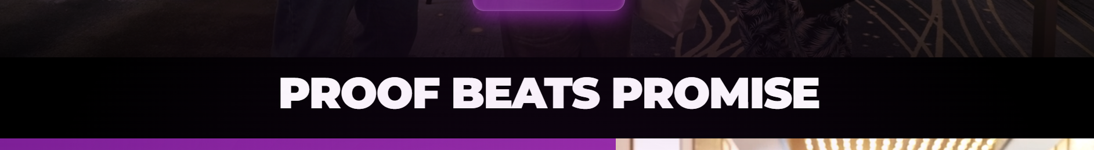
- Remove the following testimonial -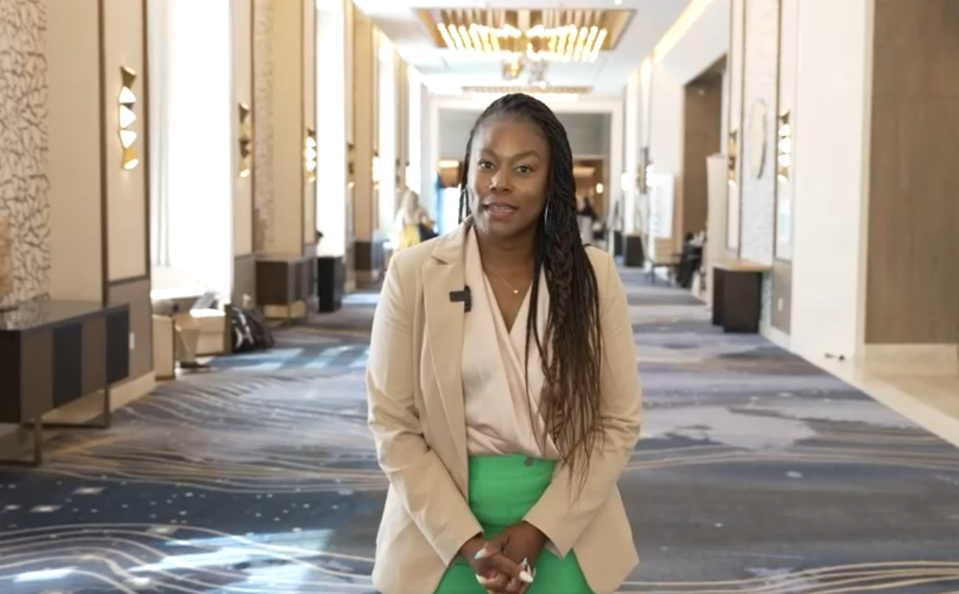

- Ensure typography capitalization matches brand rules (e.g., “CONNECT”, “tiny s”)
- Add the new Testimonials-https://drive.google.com/open?id=1SFkHQcyj-jrJa3S4kx0STKahgplyqWiP&usp=drive_fs
- Lermacus therman

- https://drive.google.com/open?id=1M-7g7qWND933f9ZwqVNR_bwLD8NnYGr_&usp=drive_fs
- Theres a third I will send
- Fix styling and positioning of all wording through out website:
- 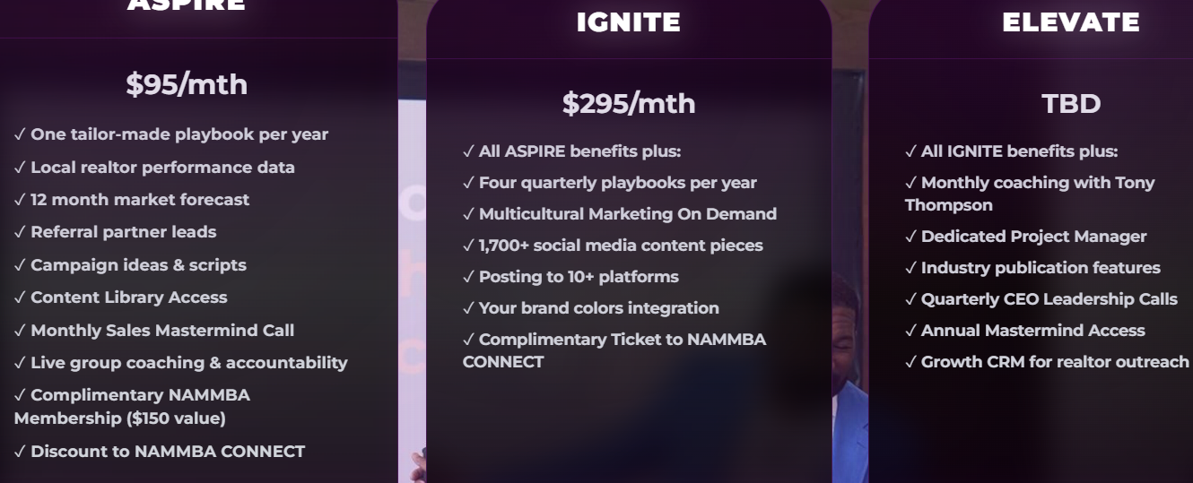
- Underneath Elevate ad By Invite Only in place of TBD
- And make the programs instead of just have a countdown have pop up windows for : PRESALE sign ups : “Your Transformation Starts Here — Join the Pre-Launch Waitlist.”

You Could Be an Ideal Fit for Our Elevate Program
- Only 1 in 50 participants reach this level — and you’re one of them.
- Let’s chat today and explore your next step.- change the pop up :
- 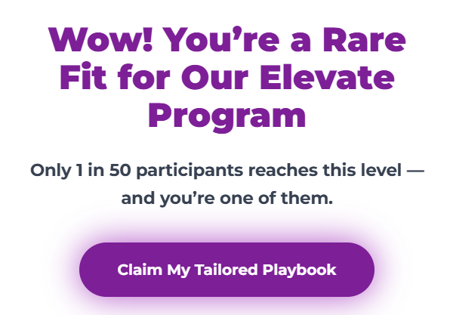
- 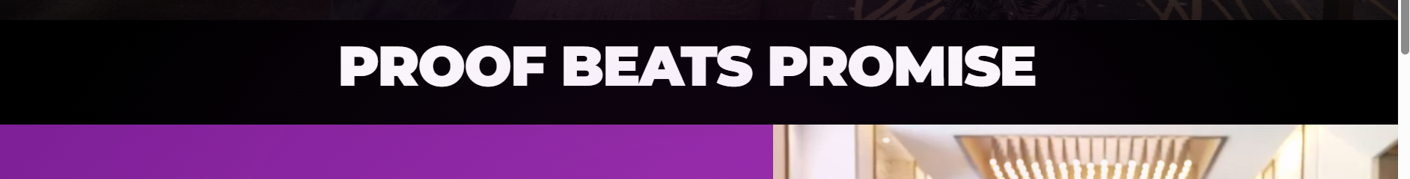
- Can we fix styling here this part feels off to the wye and check spacing everywhere
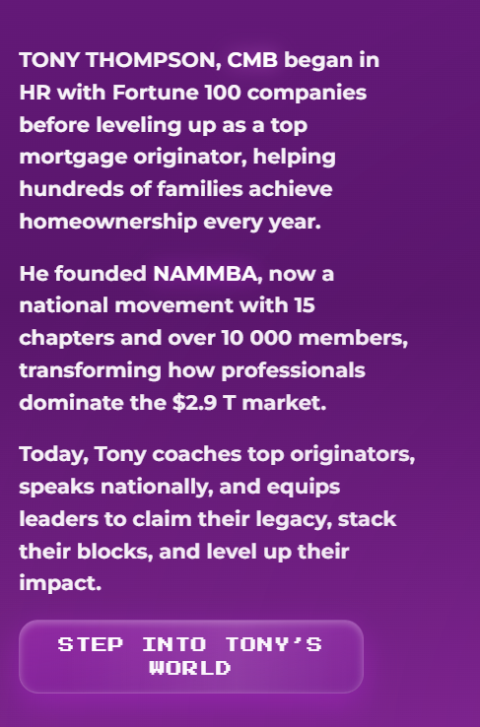
- Change step into Tony's world to learn more
- FIX styling and spacing between 2.9 T as well as ad 15 + chapters to 10 000+ members
- Change copy:Meet Tony Thompson, CMB
- Tony Thompson started in HR with Fortune 100 companies before becoming a top mortgage originator — helping hundreds of families achieve homeownership every year.
- He’s the founder of NAMMBA, a national movement with 15 chapters and over 1,000 members, transforming how professionals dominate the $2.9 trillion housing market.
- Today, Tony coaches top producers, speaks on national stages, and helps leaders build systems that multiply growth, impact, and income.
- 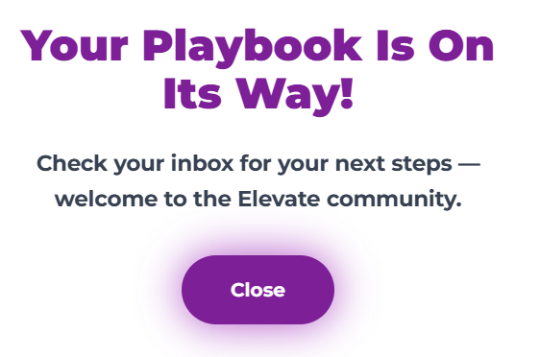
- Lets have two windows this one to claim the PDF and one to play book -which will have both PDF claim and sign up form
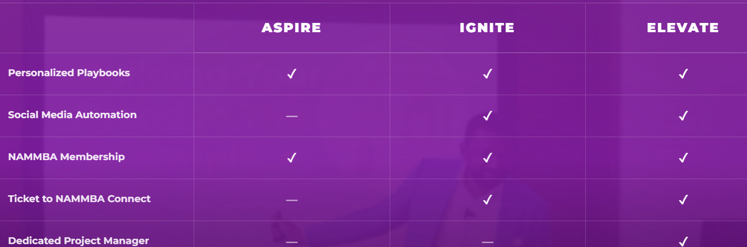
- Nammba CONNECT always in caps , place it on the second tier
- Instead of social media automation make it Social Media Marketing
- 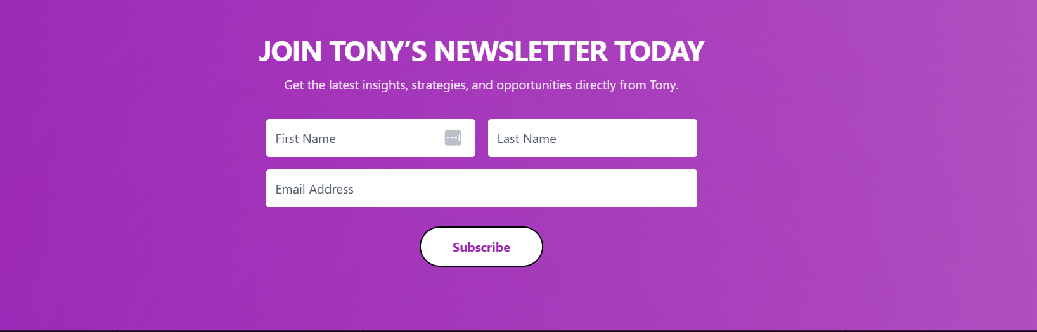
- Needs more buttons - phone number and city or state, job title
- 
- This button for Inquiries should be linked to a contact form it goes no where
- We will need to link contact forms like the one for constant contact to the sales mail (TBC)
- 
- Make sure to ad splash page for the Chasing Exellence Podcast coming soon and ad sign up form as well as for the Merch splash page and sign up form
- 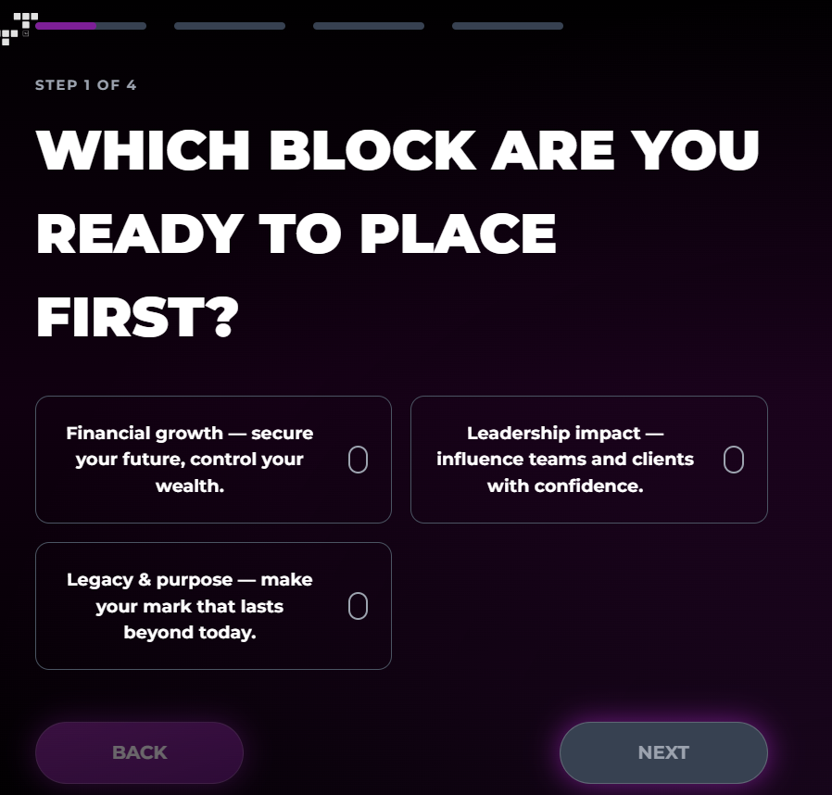
New quiz Copy How Do You Want Your Next Level to Play Out?
Discover where your biggest growth opportunity lies — and get a custom roadmap to unlock it.
Choose the outcomes that matter most to you 👇

Business Development
- I want to build predictable systems for attracting high-value clients.
- I need strategies to scale partnerships and close more deals.
- I want to strengthen leadership and team accountability.
- I’m ready to turn my network into revenue.

Marketing
- I need a marketing engine that brings in qualified leads daily.
- I want to clarify my message and dominate my niche.
- I’m ready to automate and scale my marketing.
- I want to boost visibility and become the go-to authority.

Profitability
- I want to increase revenue without burning out my team.
- I need frameworks to cut waste and improve margins.
- I’m ready to turn one-time sales into recurring income.
- I want to make every dollar I spend return 3x.

Recruiting
- I want to attract top performers who stay and grow.
- I need systems to streamline hiring and onboarding.
- I’m ready to build a culture that drives retention and performance.
- I want my team aligned, motivated, and delivering results fast.

- Brand Positioning & Copy
- Integrate “Life is extraordinary. Unleash yours” and “Unlock your tiers” as secondary headlines
- 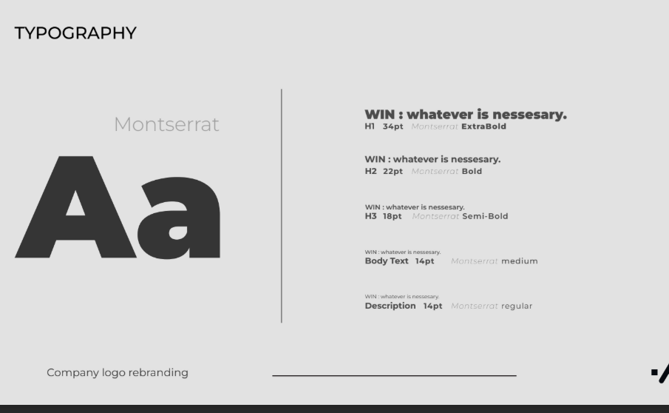
- Change typography on H2 to reflect the above cursive
- 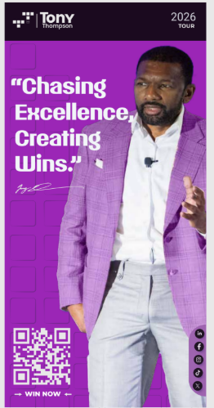
- Remove the side with logos for banner
- Make secondary banner for win/ Gold and purple
- Do the same removal on the email signature
- 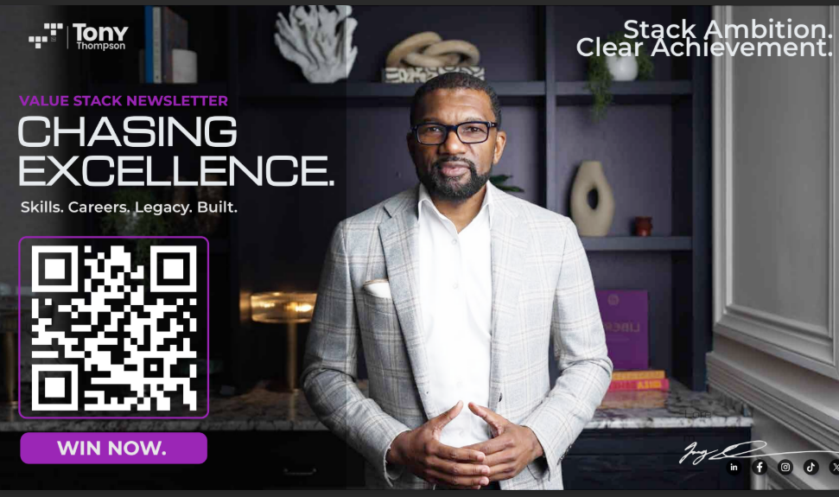
- Create this deck as a template to be editable
- 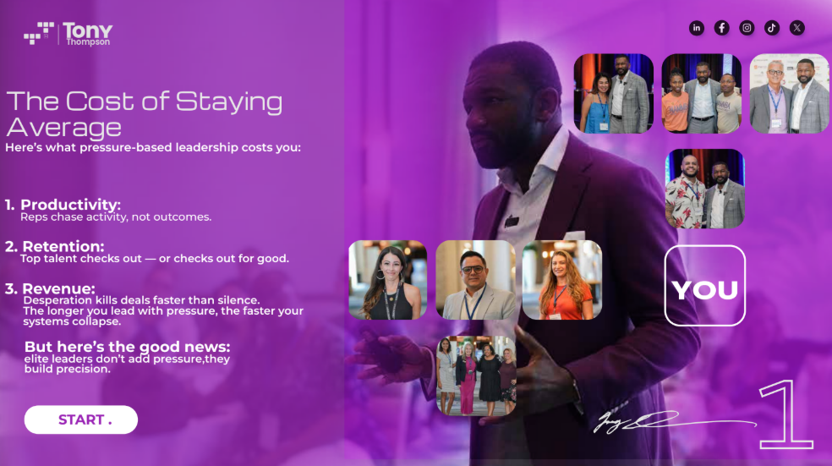
- LIGHTEN UP THIS IMAGE- BUT make parts movable for sales team to create the variations of meet Tony desks
- 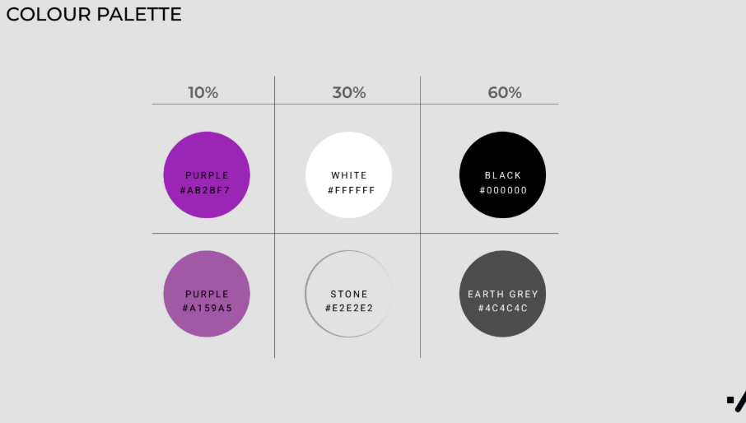
- Add Gold to Brank kit
- Update event messaging: “Events that Liberate”, “Discover Events”, “Master every area of your life”
- Add new callouts: Tony Tours, Academy/Podcast, Book Tony in main navigation

2. Website Design & User Experience
- UI Adjustments
- Replace homepage background image with Tony clapping on stage
- Add gold/purple WIN pop-up banner at top and bottom for special offers- Secondary banner
- 
- As opposed to your brand assets the slogan should be incursive like the illustration above this goes for Merch as well

- Fix newsletter/footer overlap issue
- Add “Invite Only” to event CTAs- ELEVATE
- Create “WIN” section at bottom- CTA
- Add hover pre-launch pop-ups for options/presale promo
- Ensure all CTAs link to correct sales pages

3. Lead Capture & Sales Flow
- Form Logic
- Update lead capture form:
  - Required: First Name, Last Name, Email, Phone Number
  - Optional: NML #
  - Dropdowns:BUSINESS DEVELOPMENT
  - MARKETING
  - PROFITABILITY
  - RECRUITING
  - Checkbox: Take an Assessment
- Add Job Title field and “You may be a potential…” field
- Confirm form notifications route to sales@nammba.com
- Clarify sales ownership of form submissions
- Update database sheet structure
- Update “Contact for Proper Business Growth” section
- Test form submission workflow

4. Video & Media Integration
- Place Tony video before Programs section on homepage-I need this from Michael
- Embed “Here’s why Tony created the Growth Platform” video (pop-up modal)
- Add video play hover states for testimonials
- Replace outdated testimonials with new curated versions
- Add name/title overlays on all testimonial videos
- Verify YouTube embeds and playback-We Need links from Michael
- Disable auto-playing audio sitewide

5. E-Commerce & Marketing Integrations
- Finalize Shopify and Teachable integrations
- Add Buy Now, Pay Later option (Klarna/Afterpay)
- Add Presale/MTH offer logic and countdown pop-up
- Connect social media links (Instagram, LinkedIn, YouTube)
- Integrate newsletter signup with Constant Contact
- Create Podcast Splash Page with signup form and video embed
- Add Press Kit/Media Kit: Meet Tony Thompson page
- Build Growth Platform landing page

6. Navigation & Site Architecture
- Menu items: Home, Who is Tony/About Tony, Testimonials, Programs, Tony Tours, Newsletter & Podcast, Academy/Podcast, Shop, Contact, Press Kit/Media Kit
- Add Trust & Positioning section with verified logos
- Ensure all logos are scaled and optimized for web

7. Timeline & Launch Milestones
- January 31: finalize all pre-launch deliverables
- Implement 90-Day Sales Push strategy post-launch
- Ensure pop-ups, presale CTAs, and forms are active by launch
- Schedule newsletter & branding sync meeting before deployment

8. Ownership Summary
- Tony Thompson
- Approve copy: quotes, slogans, and final tagline hierarchy
- Provide final headshot and quote images
- Approve new testimonials and videos
- Michael Muscarella
- Supply and crop new photos (Tony on stage)
- Provide logos
- Deliver and compress new videos
- Tiffany The Brand
- Oversee integration of brand kit updates
- Align forms, CTAs, and email automations with sales pipeline
- Fix typographic, alignment, and footer issues
- Create pre-launch pop-ups and presale automation flows
- Ensure embedded media and links function post-deployment

